**BIRLA INSTITUTE OF TECHNOLOGY & SCIENCE, PILANI**

**Work Integrated Learning Programmes Division**

Cluster Programme - M. Tech(AIML)

I Semester , 2022 – 23(January,2023)

Mid semester Examination (**Makeup**)

Course No : AIMLCZC418

Course Title : Introduction to Statistical Methods

Nature of Exam. : Open Book (Online)

*Number of questions:5*

*Number of Pages: 2*

Weightage : 30 Marks

Duration : 120 minutes

Date : 28th January,2023_FN

**Q.1.a).**Consider the following summary of a data. **[4M]**

Write important 4 observations from this summary which helps us to understand the data as a part of pre – processing.

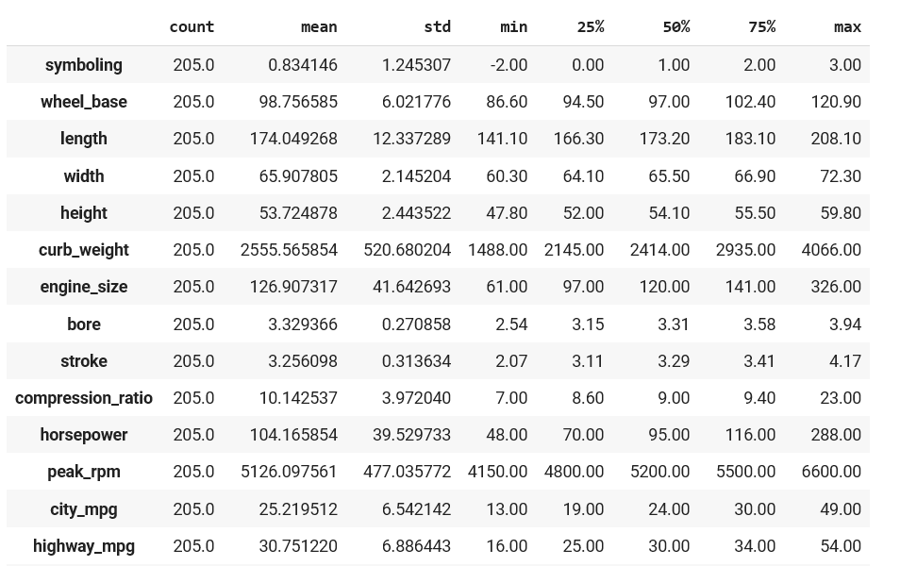

**b)**. Validate the following statement. Justify it. **[3M]**

“If two events are mutually exclusive, then they are independent also and vice versa”

**Q.2.a**).If P (A) =1/2, P (B) =1/3, P (A/B) = 1/6 find i). P(B/A) ii). P(B/A’) iii).P(AUB / A) iv).P(B/A)

v). vi). P vii). P **[4M]**

**b)**.Consider the following information related to road accidents.

Authorities identified that 15% of the road accidents are due to rash driving by self(A), 25%, 20%, 40% of road accidents are *due to bad roads(B)*, *road indiscipline by others(C)* and *various other reasons(D)* respectively. Out of these accidents (A, B, C and D) 1%, 2%, 3% and 4% died after treatment. Find the percentage of deaths due to accidents. **[3M]**

**Q.3.a).**A random variable X has the density function **[3M]**

$$f\left(x\right)=\left\{\begin{matrix}ke^{-0.5 x,}x≥0 \\ 0 elsewhere\end{matrix}\right.,$$

i).Determine k that renders f(x) as a valid density function.

ii).Find P (-1.5 < X < 2.5)

iii).Find P ([X] =1), where [X] is the greatest integer less than or equal to X

**b). Consider the following joint distribution of x and y. [4M]**

|  |  |  |  |
| --- | --- | --- | --- |
| p(x,y) | x | | |
| y |  | 1 | 2 |
| 1 | 0.15 | 0.15 |
| 2 | 0.20 | 0.20 |
| 3 | 0.05 | 0.10 |
|  | 4 | 0.05 | 0.10 |

1. Validate the distribution
2. Find Marginal distributions of x,y
3. Find P(Y = 2/ X < 2)
4. Are they independent random variables?

**Q.4.a).** If possible, find the probability distribution function of a binomial distribution with mean 4 and variance 4/3.  **[3M]**

**b).** The life of a certain kind of electronic device has a mean of 250 hours and a standard deviation of 20 hours. Assuming that he distribution of life times which are measured to the nearest hour can be approximated closely with a normal curve, **[3M]**

(i) Find the probability that any one of these devices will have a lifetime of more than 200 hours.

(ii) What percentage will have life time from 250 to 300 hours.

**Q.5**. It is observed that waiting time of patients in a hospital is 15 minutes with a Standard deviation of 2 minutes. Sampling is used to validate this observation. Find the probability that the sampling mean lies between 12 to 17 minutes with sample size of 35**. [3M]**

XXXXXX